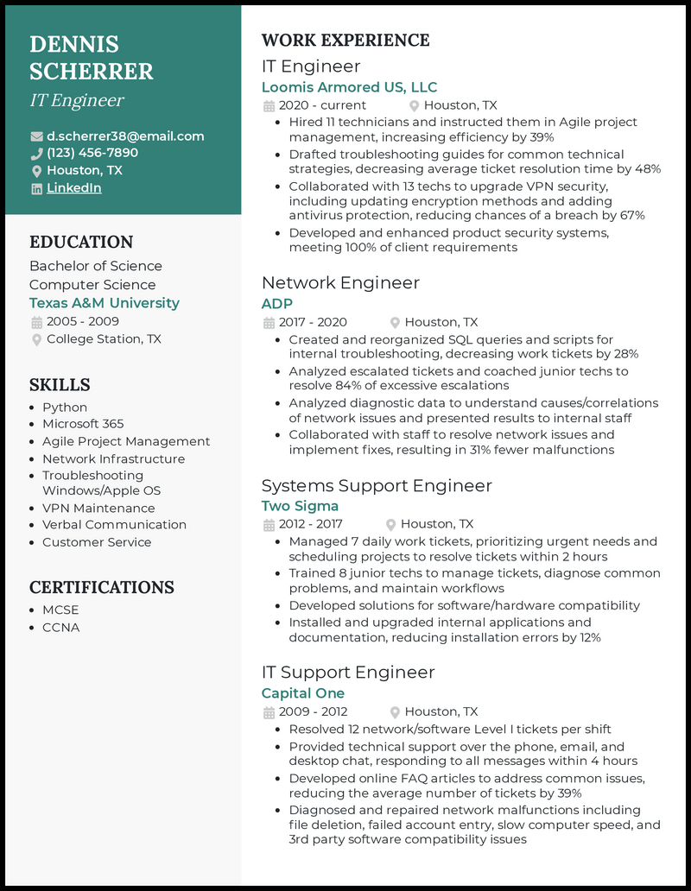
DENNIS SCHERRER
IT Engineer
d.scherrer38@email.com (123) 456-7890
Houston, TX in LinkedIn
EDUCATION
Bachelor of Science Computer Science Texas A&M University
2005-2009
College Station, TX
SKILLS
• Python
• Microsoft 365
• Agile Project Management
• Network Infrastructure
• Troubleshooting
Windows/Apple OS
• VPN Maintenance
• Verbal Communication
• Customer Service
CERTIFICATIONS
• MCSE
• CCNA
WORK EXPERIENCE
IT Engineer
Loomis Armored US, LLC
2020 - current
Houston, TX
• Hired 11 technicians and instructed them in Agile project management, increasing efficiency by 39%
• Drafted troubleshooting guides for common technical strategies, decreasing average ticket resolution time by 48% • Collaborated with 13 techs to upgrade VPN security, including updating encryption methods and adding antivirus protection, reducing chances of a breach by 67% • Developed and enhanced product security systems, meeting 100% of client requirements
Network Engineer
ADP
2017-2020
Houston, TX
• Created and reorganized SQL queries and scripts for internal troubleshooting, decreasing work tickets by 28% • Analyzed escalated tickets and coached junior techs to resolve 84% of excessive escalations
• Analyzed diagnostic data to understand causes/correlations of network issues and presented results to internal staff
• Collaborated with staff to resolve network issues and implement fixes, resulting in 31% fewer malfunctions
Systems Support Engineer
Two Sigma
2012-2017
Houston, TX
• Managed 7 daily work tickets, prioritizing urgent needs and scheduling projects to resolve tickets within 2 hours
• Trained 8 junior techs to manage tickets, diagnose common problems, and maintain workflows
• Developed solutions for software/hardware compatibility • Installed and upgraded internal applications and documentation, reducing installation errors by 12%
IT Support Engineer
Capital One
2009 - 2012
Houston, TX
• Resolved 12 network/software Level I tickets per shift • Provided technical support over the phone, email, and desktop chat, responding to all messages within 4 hours • Developed online FAQ articles to address common issues, reducing the average number of tickets by 39%
• Diagnosed and repaired network malfunctions including file deletion, failed account entry, slow computer speed, and 3rd party software compatibility issues

